Test Case: tc001_SPX_Dev5_Crear_Requisicion_Spot_Tipo_Cobro_CC
Step 1 - Enter username and password and click to button Enter : Credentials Entered
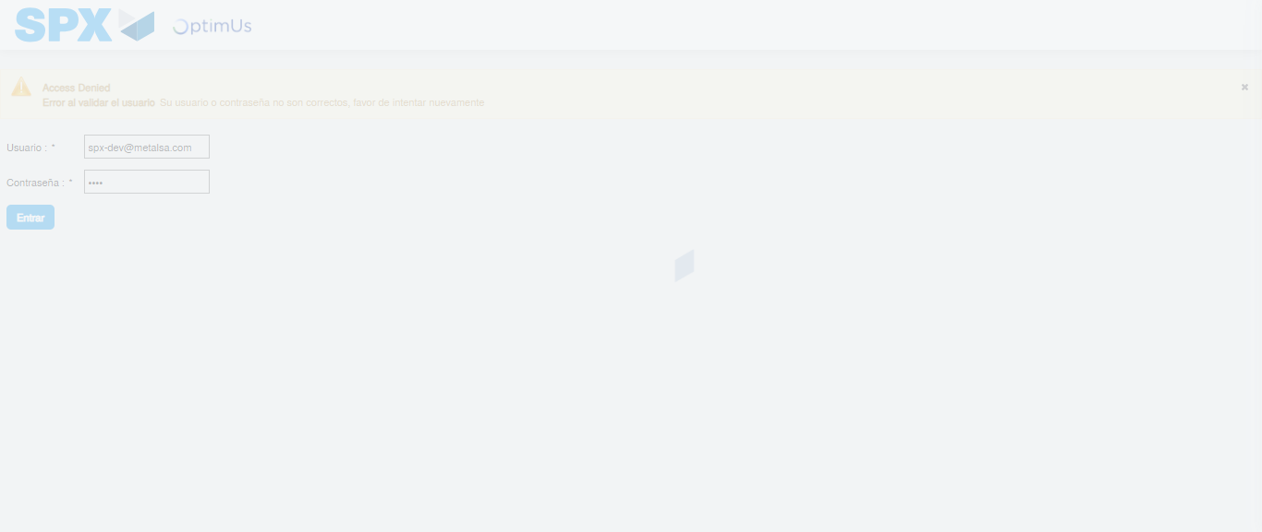Image file-name: QC_Testing-tc001_SPX_Dev5_Crear_Requisicion_Spot_Tipo_Cobro_CC-1789482314275

Step 2 - Select to UEN and Access to Spot Buy Requisitions : UEN Correctly selected and Correct access
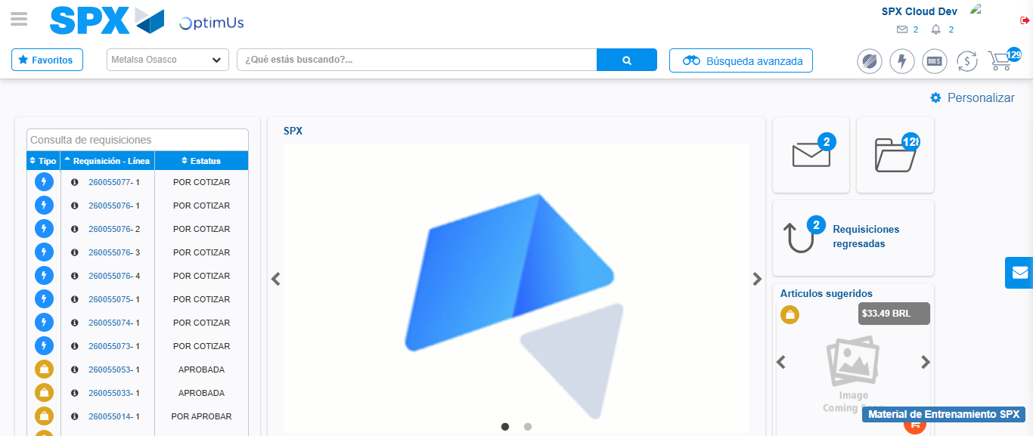Image file-name: QC_Testing-tc001_SPX_Dev5_Crear_Requisicion_Spot_Tipo_Cobro_CC-1789482337165

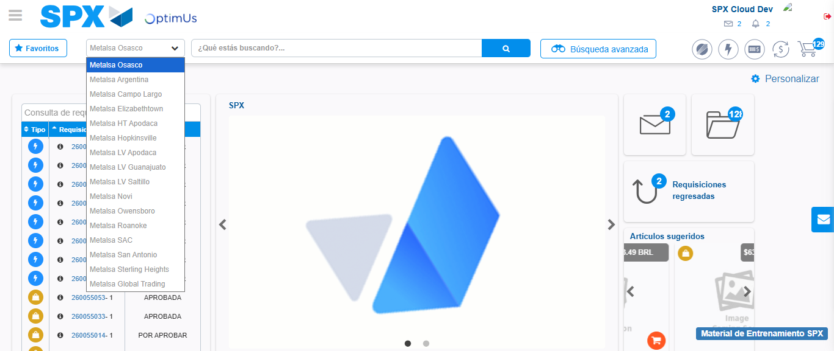Image file-name: QC_Testing-tc001_SPX_Dev5_Crear_Requisicion_Spot_Tipo_Cobro_CC-1789482337966

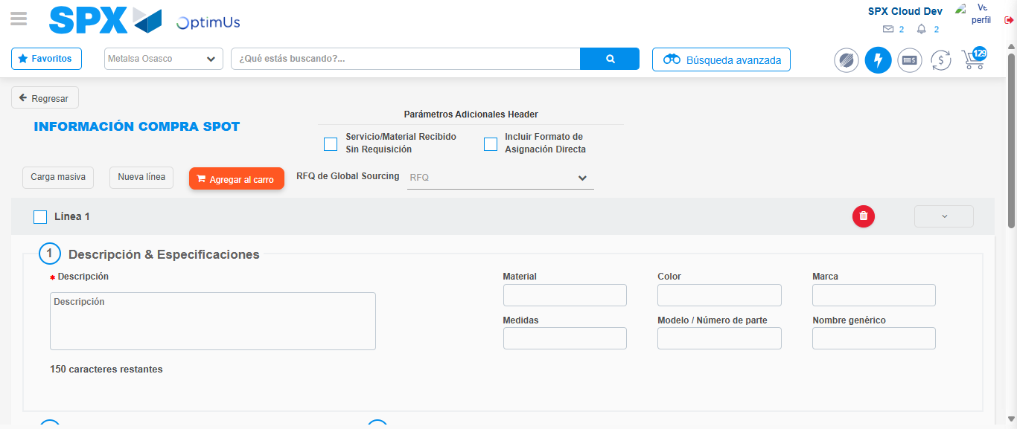Image file-name: QC_Testing-tc001_SPX_Dev5_Crear_Requisicion_Spot_Tipo_Cobro_CC-1789482343110

Step 3 - Data Capture Spot Buy Requisition : Data captured correctly
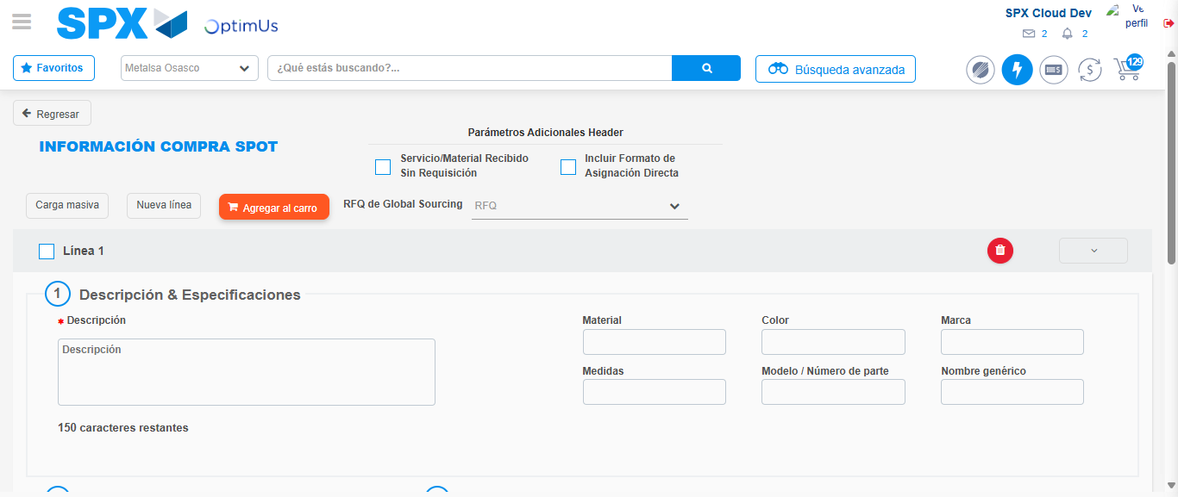Image file-name: QC_Testing-tc001_SPX_Dev5_Crear_Requisicion_Spot_Tipo_Cobro_CC-1789482343457

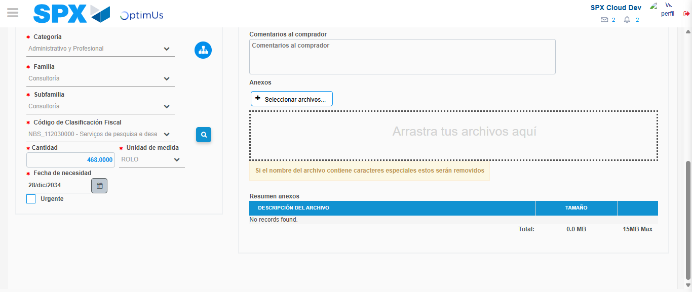Image file-name: QC_Testing-tc001_SPX_Dev5_Crear_Requisicion_Spot_Tipo_Cobro_CC-1789482360271

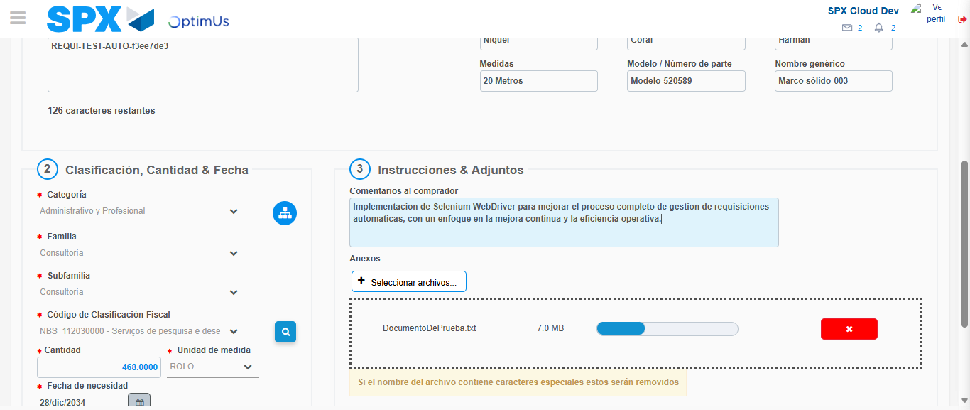Image file-name: QC_Testing-tc001_SPX_Dev5_Crear_Requisicion_Spot_Tipo_Cobro_CC-1789482361227

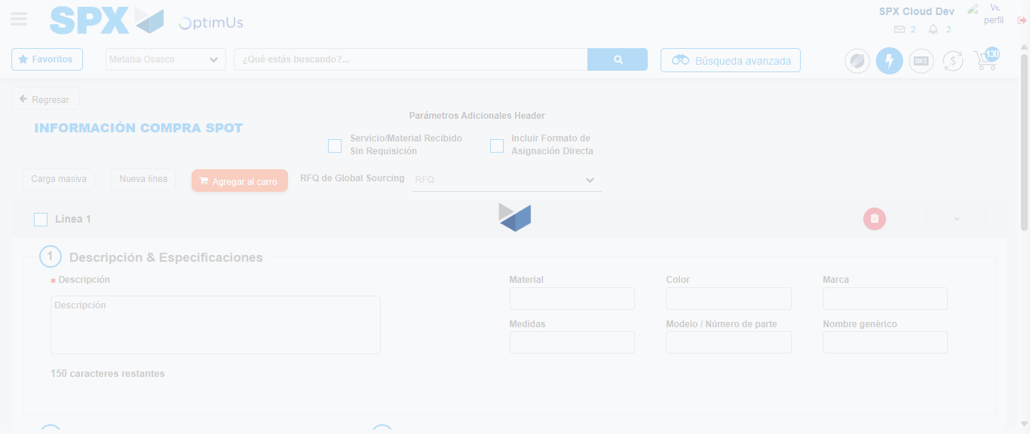Image file-name: QC_Testing-tc001_SPX_Dev5_Crear_Requisicion_Spot_Tipo_Cobro_CC-1789482362758

Step 7 - Return to Main Page SPX : Return to Main Page SPX
Image file-name: QC_Testing-tc001_SPX_Dev5_Crear_Requisicion_Spot_Tipo_Cobro_CC-1789482337165

Image file-name: QC_Testing-tc001_SPX_Dev5_Crear_Requisicion_Spot_Tipo_Cobro_CC-1789482337966

Image file-name: QC_Testing-tc001_SPX_Dev5_Crear_Requisicion_Spot_Tipo_Cobro_CC-1789482343110

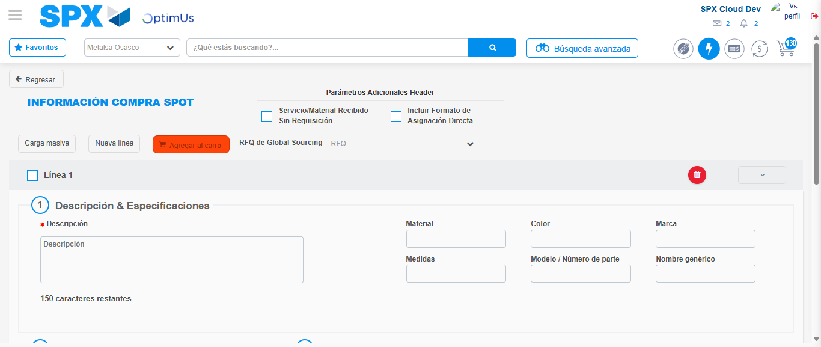Image file-name: QC_Testing-tc001_SPX_Dev5_Crear_Requisicion_Spot_Tipo_Cobro_CC-1789482365104

Image file-name: QC_Testing-tc001_SPX_Dev5_Crear_Requisicion_Spot_Tipo_Cobro_CC-1789482365289

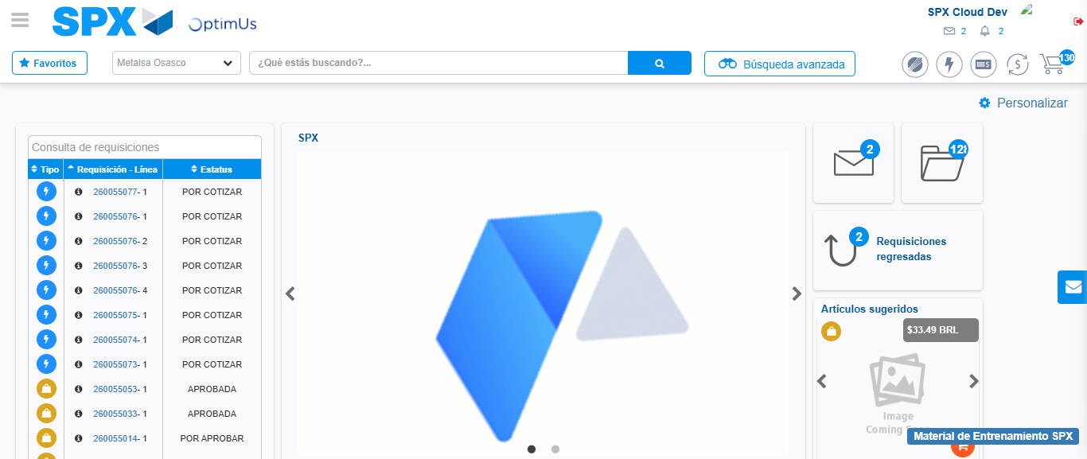Image file-name: QC_Testing-tc001_SPX_Dev5_Crear_Requisicion_Spot_Tipo_Cobro_CC-1789482393859

Step 8 - Log Out : Log Out SPX
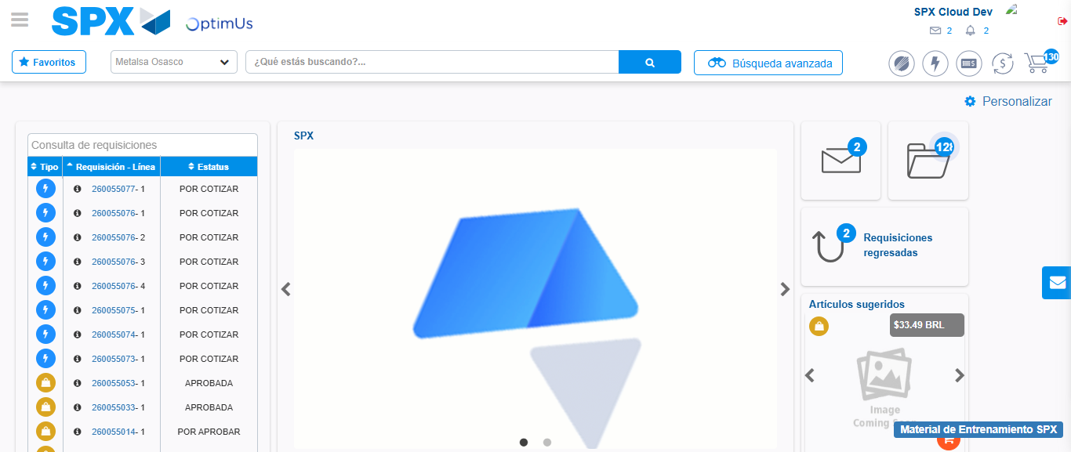Image file-name: QC_Testing-tc001_SPX_Dev5_Crear_Requisicion_Spot_Tipo_Cobro_CC-1789482394191

